*Every Week: Monday Cribbage & Knitting, Thursday YMCA & Friday Cards* |  | March 2026
Sunday | Monday | Tuesday | Wednesday | Thursday | Friday | Saturday
1 1PM - 3PM | 2 1PM – 6PM | 3 | 4 | 5 9:30AM | 6 5PM | 7
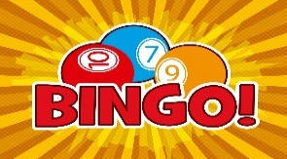 | 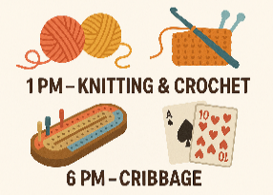 |  |  |  |  | 
8 1PM – 3PM | 9 11AM | 10 | 11 | 12 9:30AM | 13 1PM to 3PM  NNNN | 14
 | Painting with DeeDino  &  Tenant Meeting at 1PM |  |  |  |  | 
15 1PM – 3PM | 16 1PM | 17 | 18 11AM | 19 9:30AM | 20 11AM | 21
 |  |   Board Meeting 4PM |  |  |  | 
22 1PM – 3PM | 23 10AM | 24 | 25 | 26 9:30AM | 27 1PM | 28
 |  |  |  |  |  | 
29 1PM – 3PM | 30 1PM – 6PM | 31
 | 